The Literacy Learning Progressions: Meeting the Reading and Writing Demands of the Curriculum describe the literacy-related knowledge, skills, and attitudes that students need to draw on to meet the demands of the curriculum.  Defending the Dark  by Matt Boucher  Connected  Level 4  2019  The Learning Progression Frameworks (LPF) describe significant signposts in reading and writing as students develop and apply their literacy knowledge and skills with increasing expertise from school entry to the end of year 10.  Overview  This article introduces the science of astronomy while explaining the issue of light pollution and practical ways of reducing it. It raises awareness of why this issue is so important for humans and our fellow creatures.  A Google Slides version of this article is available at www.connected.tki.org.nz | 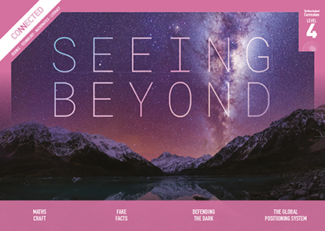  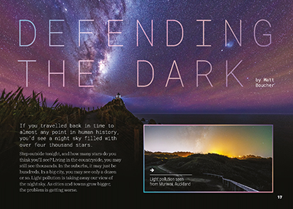
Curriculum contexts

SCIENCE: Nature of Science: Participating and contributing  Level 4 – Students will use their growing science knowledge when considering issues of concern to them.  SCIENCE: Planet Earth and Beyond: Astronomical systems  Level 4 – Students will investigate the components of the solar system, developing an appreciation of the distances between them. | Key science ideas  - Light in the environment blocks vision of the stars in the night sky.  - We can see more objects in the sky when there is less light around us.  - Stars and galaxies that we see at night are much further away than our star, the sun, which sits at the centre of our solar system. Light from these stars takes many years to reach us.
TECHNOLOGY: Nature of Technology: Characteristics of technology  Level 4 – Students will understand how technological development expands human possibilities and how technology draws on knowledge from a wide range of disciplines. | Key technology ideas  - Societal and environmental issues can influence technological outcomes.
ENGLISH: Reading  Level 4 – Ideas: Students will show an increasing understanding of ideas within, across, and beyond texts. | Indicators:  - makes meaning of increasingly complex texts by identifying and understanding main and subsidiary ideas and the links between them  - makes connections by thinking about underlying ideas within and between texts from a range of contexts  - recognises that there may be more than one reading available within a text  - makes and supports inferences from texts with increasing independence.

The New Zealand Curriculum

Meeting the literacy challenges

The main literacy demands of this text arise from the interpretation of scientific information relating to astronomical phenomena. However, little prior knowledge is needed as the writer carefully breaks the information down, with each section starting on a new page. Photographs, diagrams, and breakouts help explain the information in the running text.  The text includes topic-specific vocabulary and words in te reo Māori. Much of this is explained in the text, in the breakouts, and in a glossary. There are also some long, complex sentences that contain a lot of information.  The following strategies will support students to understand, respond to, and think critically about the information and ideas. | The instructional strategies below support students to meet the literacy challenges of this text. For each strategy, there are links to the relevant aspect of The Learning Progression Frameworks (Reading). The signposts on each of these aspects provide detailed illustrations on what to notice as your students develop their literacy knowledge and skills for different purposes in different curriculum areas.  You may wish to use shared or guided reading, or a mixture of both approaches, depending on the reading expertise of your students and the background knowledge they bring to the text.  After reading the text, support students to explore the activities outlined in the following pages.

INSTRUCTIONAL STRATEGIES

Finding the main ideas  [LPF Reading: Acquiring and using information and ideas in informational text]  Have the students read the title and first paragraph. ASK QUESTIONS to help them make connections to their prior knowledge and to identify the main idea.  How many stars do you think we can see in the night sky here? How does this compare with other places you’ve been?  Where was the most magnificent night sky you have ever seen? What could you see?  The writer calls light pollution a problem. Is it really? Apart from not being able to see the pretty stars, what do you think makes it a problem?  Using text structure and features  [LPF Reading: Making sense of text: using knowledge of text structure and features]  PROMPT the students to recall text structures they are familiar with, such as compare and contrast, description, problem–solution, cause and effect, explanation, and sequence of events.  What did we decide was the text structure for …? Why did we think the writer chose that structure?  Based on what we have read so far, what sort of structure is this text likely to follow? Let’s scan the rest of the text to find out. | The students will notice that most of the text follows a problem–solution structure. The exception is the stargazing tips on page 24. DISCUSS how this could be captured in a graphic organiser, such as the one below. Remind the students that the purpose of a graphic organiser is to capture succinct notes so they don’t need to write complete sentences.  Defending the Dark – Problems/solutions chart  What is the problem? What is the cause? What is the effect? What are possible solutions?  TELL the students that while this is quite a straightforward article, it does include some long, complex sentences. It’s important to keep an eye out for the connectives – the conjunctions, prepositions, and adverbs that join parts of a sentence together. DISCUSS what these grammatical terms are and list some examples on the board. Then have the students read page 18 to find the connectives and identify their purpose.  You could use the table below for additional support, particularly if you have students who are English language learners. Use the blank spaces for them to record and talk through examples from the text. See also Exploring language: A handbook for teachers.

Meeting the literacy challenges

connectives Words or phrases that link clauses or sentences. Connectives can be conjunctions or connecting adverbs.  conjunctions Words that are used to link clauses within a sentence (for example, but, when, because, although). There are two types of conjunction: co-ordinating conjunctions and subordinating conjunctions.  co-ordinating conjunctions Words that join and are placed between two clauses of equal weight (for example, and, but, or, so). And, but, and or are also used to join words or phrases within a clause.  subordinating conjunctions Words that go at the beginning of a subordinate clause (for example, when, while, before, after, since, until, if, because, although).  connecting adverbs (and adverbial phrases and clauses) Words and phrases that connect ideas while keeping the clauses separate. They are often marked off by commas. Connecting adverbs connect ideas through: - addition (for example, also, furthermore, moreover) - opposition (for example, however, nevertheless, on the other hand) - reinforcing (for example, besides, anyway, after all) - explaining (for example, in other words, that is to say) - listing: (for example, first(ly), first of all, finally) | - indicating result (for example, therefore, consequently, as a result)  - indicating time (for example, just then, meanwhile, later).  Using visual features for deeper understanding  [LPF Reading: Making sense of text: using knowledge of text structure and features]  EXPLAIN that diagrams and photographs are often used in science writing. DISCUSS the purpose of each of the visual features in this text. Choose one and model going backwards and forwards between it and the text to make sense of the overall concept. Ask the students to select one and explain to a partner how it helps them to understand the information in the article.  Dealing with unfamiliar vocabulary  [LPF Reading: Making sense of text: vocabulary knowledge]  Have the students IDENTIFY and LIST the vocabulary that is new to them. Then have them SORT the vocabulary according to how they worked out the meanings of the words. Categories could include:  - I know this word from another context.  - I found a clue to the meaning in the text.  - I predicted this meaning from reading the text.  - The word is in the glossary.  - We use this word in technology.  - We use this word in science.  - I can see the meaning from the illustration.  - I found the word in the dictionary.  - I found the word in a thesaurus.  Create a classroom word bank that includes these words.  Have the students go to Te Aka Māori–English, English–Māori Dictionary to learn more about the meaning of the words in te reo Māori and to hear how they are pronounced.

The Learning Progression Frameworks
The Literacy Learning Progressions
Effective Literacy Practice: Years 5–8

Illustrating the key ideas
Light in the environment blocks vision of the stars in the night sky.

Societal and environmental issues can influence technological outcomes. | 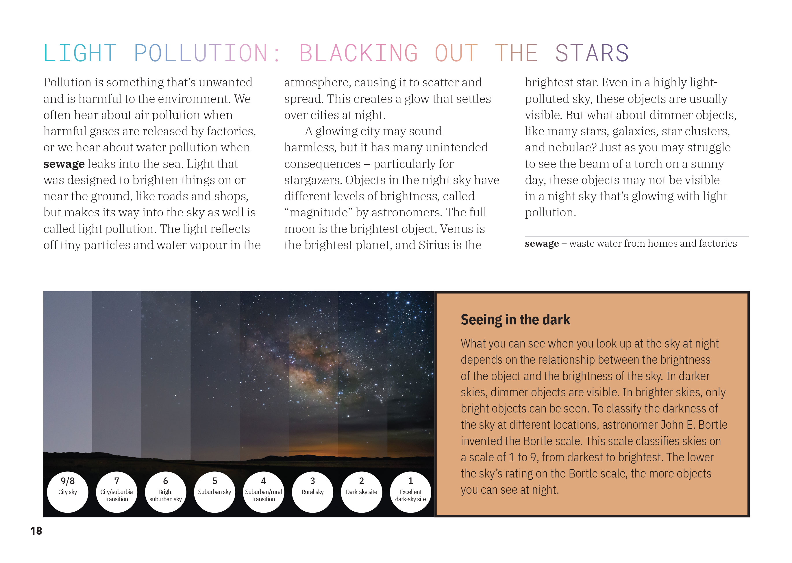  We can see more objects in the sky when there is less light around us.

Learning activities – Exploring the science
and technology

Activity 1 – The night sky  The Globe at Night is an online citizen science project that involves measuring and recording the brightness of the sky in the local area. Go to Science Learning Hub to learn about how Melissa Coton’s class at Boulcott School used the Globe at Night to develop their capability to critique evidence. The Hub’s case study includes her unit plan, some of the activities, and information about Globe at Night.  The School Journal, Level 2, October 2015, features some great photographs of stars taken by Tunç Tezel, an award-winning photographer from Turkey. Tunç specialises in astrophotography – taking photos of the night sky. In an interview printed in the School Journal, Level 2, May 2016 (“Tunç Tezel: Star Man”), Tunç explains what motivates him and how he carries out his craft. Students will get another insight into why light pollution is so problematic. Tunç is a contributor to the website The World at Night. Take students there to explore more dramatic images of the night sky.  Arrange a visit to an observatory or invite the local astronomy club to run a star night at the school. There may be also be parents, whānau, or local kaumātua with specialist expertise.  Professor Rangi Matamua is a fifth generation Māori astronomer on a mission to disseminate star lore left to him by his tīpuna. Professor Matamua welcomes the resurgence of interest in Māori astronomy that has come with the revival of Matariki but believes there is much more to share. He uses a variety of channels, including a Facebook page called Living by the Stars. This includes videos that are also available with English subtitles via Instagram. Anyone can interact with Professor Matamua through his Facebook page on a Monday evening. The resources he has created provide a special way for students to engage with a Māori perspective on the night sky and to help them understand the need to be a proactive kaitiaki of the environment.  Extending the learning  There are multiple ways in which students could respond to and extend their learning about the night sky. For example, they could:  - investigate the significance of certain constellations for people of different cultures  - investigate the impact of light pollution on the circadian rhythms of people and wildlife (see the Connected 2015 article “Sleep Sleuths”)  - investigate why Tunç Tezel thinks the night sky in New Zealand is more interesting than it is in Turkey | The following activities and suggestions are designed as a guide for supporting students to explore and extend their content knowledge across the learning areas. Adapt these activities to support your students’ interests and learning needs.  - investigate how astronomy is used in a particular context, such as for gardening or navigation  - study the relationship between light and photography and experiment with astrophotography  - create a visual representation of the solar system  - design a digital outcome that supports people to learn the names of the stars and their meanings  - investigate the campaign to make Stewart Island a dark sky sanctuary  - explore ideas for improving lighting  - campaign to reduce light pollution locally.  Activity 2 – Learning about light  The students could investigate light itself – sources of light, how light waves work, and how they can create their own light displays.  See the resource links below for Building Science Concept books to support learning about light.  Light is the subject of a number of Connected items. For a digital technology connection, see “Lighting the Sky with Raspberry Pi” in Connected 2018. It describes how students at Fernridge School used Raspberry Pi computers to create a digital light display for Matariki. Its TSM includes suggestions for how your students could engage in similar activities that extend their understanding of coding and electrical circuits.  Citizen science is a great way of getting students excited about their learning. “Light detectives” is a case study on the Science Learning Hub that shows how Matt Boucher, the article’s writer, extended and applied his year 7 and 8 students’ learning about light. As part of the unit, the students engaged in two citizen science projects: Agent Exoplanet and Planet Hunters. Both involved the students in interpreting existing data collected with space telescopes – data they could not have collected on their own. Both involve identifying light patterns produced by exoplanets (planets that orbit stars other than our sun).

RESOURCE LINKS

Connected and School Journal  “Cool Facts about a Hot Place”, Level 2, School Journal, October 2015  “The Sons of Ma‘afu”, Level 2, School Journal, October 2015  “Tunç Tezel: Star Man”, School Journal, Level 2, May 2016  “Lighting the Sky with Raspberry Pi”, Connected 2018, Level 2, Step by Step  “Catching a Space Duck”, Connected 2015, Level 3, Fact or Fiction?  “Sleep Sleuths”, Connected 2015, Level 3, Fact or Fiction?  Science Learning Hub  Globe at night: https://www.sciencelearn.org.nz/resources/2726-globe-at-night  Loss of the night: https://www.sciencelearn.org.nz/resources/2765-loss-of-the-night  Fascinating astronomy: https://www.sciencelearn.org.nz/resources/2190-fascinating-astronomy  Constellations in the night sky: https://www.sciencelearn.org.nz/resources/635-constellations-in-the-night-sky  The Matariki star cluster: https://www.sciencelearn.org.nz/resources/2322-the-matariki-star-cluster  Light detectives – case study: https://www.sciencelearn.org.nz/resources/2729-light-detectives-case-study  Building Science Concepts  Book 8: The Moon: Orbits, Appearances, and Effects  Book 10: Light and Colour: Our Vision of the World  Book 11: Seeing Colours: The Spectrum, the Eye, and the Brain  Book 27: Exploring Space: Discovering Our Place in the Universe  Book 28: The Night Sky: Patterns, Observations, and Traditions  Making Better Sense of Planet Earth and Beyond  Science focus: Astronomy  Making Better Sense of the Physical World  Science focus: Light | Exploring language: A handbook for teachers: https://englishonline.tki.org.nz/English-Online/Planning-for-my-students-needs/Exploring-language  International Dark-Sky Association  Aoraki Mackenzie International Dark Sky Reserve (New Zealand): http://www.darkskyreserve.org.nz/  International dark sky reserves: https://www.darksky.org/our-work/conservation/idsp/reserves/  Materials for educators: https://www.darksky.org/our-work/grassroots-advocacy/resources/educators/  Videos: https://www.darksky.org/our-work/grassroots-advocacy/resources/videos/  YouTube channel: https://www.youtube.com/user/IntDarkSkyAssoc  Other sources  Backpacker guide NZ: What is a dark sky reserve? https://www.backpackerguide.nz/what-is-a-dark-sky-reserve/  Mackenzie region: Aoraki Mackenzie International Dark Sky Reserve: https://mackenzienz.com/scenic-highlights/dark-sky-reserve/  Tekapo Tourism: University of Canterbury’s Mt John Observatory: http://www.tekapotourism.co.nz/info/mt_john.html  National Park Service: Yellowstone / Dark Skies: https://www.nps.gov/yell/learn/nature/dark-skies.htm  Agent Exoplanet: https://agentexoplanet.lco.global/  Zooniverse planet hunters TESS: https://www.zooniverse.org/projects/nora-dot-eisner/planet-hunters-tess  The world at night (TWAN): http://twanight.org/newTWAN/index.asp  Living by the stars with Professor Rangi Matamua: https://www.facebook.com/Livingbythestars/  New Zealand astronomy directory: http://nzastronomy.co.nz/  Ngā Whetū resources: http://ngawhetu.nz/index.php  Skyglow: https://skyglowproject.com/  Te Aka Māori–English, English–Māori Dictionary: https://maoridictionary.co.nz/

